**UNDERSTANDING THE WORLD BEFORE SPRING BOOT**

* Setting up Spring Projects before Spring Boot was NOT easy!
* We needed to configure a lot of things before we have a production-ready application.

1. 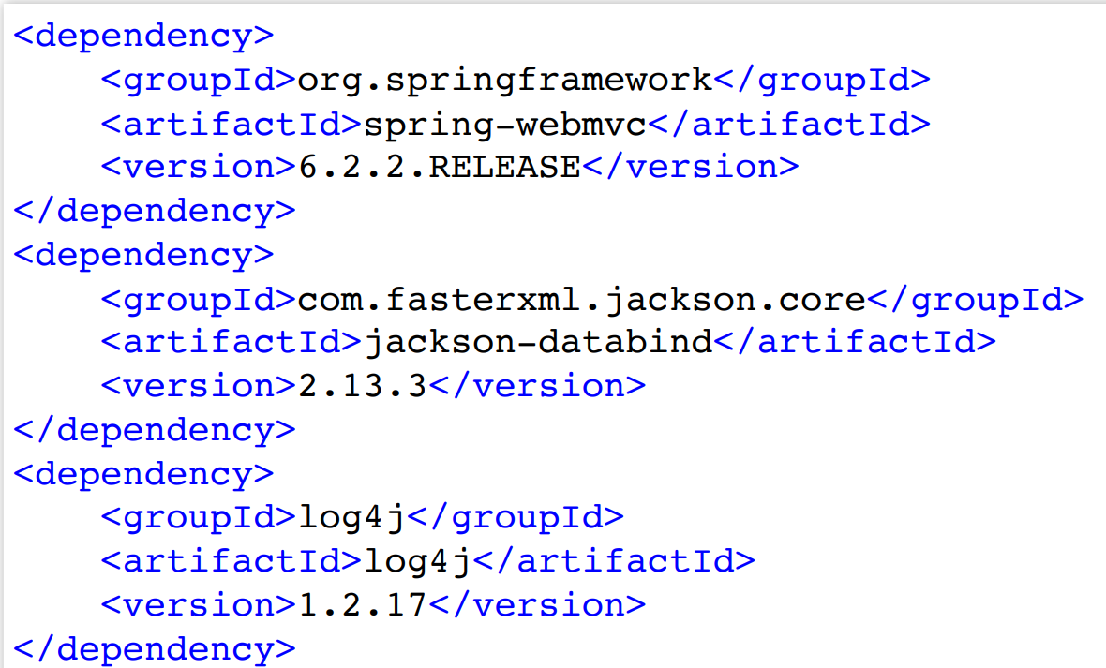**Dependency Management**

* Manage frameworks and versions.
  + REST API - Spring framework, Spring MVC framework, JSON binding framework, ...
  + Unit Tests - Spring Test, Mockito, JUnit, ...

1. **Graphical user interface, text, application, email

   Description automatically generatedWeb.xml**

* Example: Configure DispatcherServlet for Spring MVC

1. **Spring Configuration**

* Define your Spring Configuration
  + Component Scan
  + View Resolver

1. **Non-Functional Requirements**

* Logging
* Error Handling
* Monitoring
* Setting up Spring Projects before Spring Boot was NOT easy!
  + 1: Dependency Management (pom.xml)
  + 2: Define Web App Configuration (web.xml)
  + 3: Manage Spring Beans (context.xml)
  + 4: Implement Non-Functional Requirements (NFRs)
* AND repeat this for every new project!
* Typically takes a few days to setup for each project (and countless hours to maintain)